Forestry and Wood Update………October 2011 - Volume 11 Number 4CONTENTS
Information and support services 2
Timber Standards Development in Ireland - an update 2
Firewood Market shows strong growth 2006 - 2010 5
Carbon Corner6
New Publications Available 7

Events 8
Tending and thinning of Oak Woodlands 26 October 2011 8
Innovative Wood Display lights up Electric Picnic 9
Arboricultural Association Training Course 26 October 2011 10
RDS - Forest Service Irish Forestry Annual Awards 18 October 2011 11
Tree Day 6 October 2011 15
National Trails Day 2 October 2011 14
National Ploughing Championships 22 September 2011l 15

Research Programme 16
Climadapt update 16
Grass seeding clearfelled blanket bogs - a novel solution to mitigate Phosphorus release after forest harvesting 16
Economic contribution of forest sector 2010 18

National and international news 18
Technology collaboration 18
Joint Research Centre - European Forest Fire Information System (EFFIS) 18
OFORD
Department of Agriculture, Food and the Marine
Agriculture House
Kildare Street
Dublin 2
Ireland
Tel: +353 - 1 - 6072000
Email: info@coford.ie
Web: www.coford.ie
COFORD’s activities are funded by the Irish Government under the National Development Plan.

PLEASE CIRCULATE THIS NEWSLETTER TO YOUR COLLEAGUES AND OTHER INTERESTED PARTIES

TO SUBSCRIBE TO THE NEWSLETTER, CLICK HERE

Newsletter compiled and edited by Orla Cashen, John Fennessy and Eugene Hendrick, Forest Sector Development Division (FSD), DAFM.

For further information please contact orla.cashen@agriculture .gov.ie

Information and support services

Timber standards development in Ireland – an update
Timber standards in Ireland are monitored and developed under the auspices of the Timber Standards Consultative Committee of the NSAI. The committee has been active in the past year in revising and developing new standards to enable more up-to-date approaches to the use of timber in construction and in other applications. The specification and use of structural timber products is critically dependent on product and design standards. Forest Sector Development Division has provided grant aid to support this important work. This note outlines recent developments in the area.
The period of co-existence between national standards and European standards came to an end in March 2010 and any standards conflicting with European standards had to be withdrawn by that date. Thus, for structural timber, in Ireland, I.S. 193 (Roof trusses) and I.S. 444 (The use of structural timber in buildings) were withdrawn while in the UK the main design standards BS 5268 (Parts 2 –general design, 3 – roof trusses, 4 – fire design and 6 – timber frame wall design) were also withdrawn. The Irish standards were based on BS 5268-2 which was a permissible stress design standard while EC5 is a limit state standard and involves much more complicated design procedures.
When an EN (European Standard) is published by CEN, member states must adopt the standard and remove any conflicting national standard. Thus, an EN in Ireland becomes an I.S. EN and in Britain it would become a BS EN. The contents of the standards are the same for all member states; they are not allowed to change the standard (except for a small number of ‘boxed’ values) but are allowed to have a National Annex and to produce NCCI (Non-Contradictory Complimentary Information) documents. A NCCI tends to give additional information and are voluntary; designs to a European standard do not have to follow an NCCI. National Annexes tend to give certain values for boxed valued which relate to national levels of safety; the UK National Annex seems to go a little further and some of the contents would appear to belong in a NNCI. The National Annexes should be followed for designs for buildings being constructed in the particular member state.
The change over also involves the use of European loading standards; the main ones being EN 1991-1-4 (wind), EN 1991-1-1 (dead and imposed loads) and EN 1991-1-3 (snow). A number of product ENs have been in existence for some time e.g. EN 300 for OSB boards, EN 636 for plywood as well as the ‘umbrella’ board standards EN 13986.
As EN product standards have been published, Irish Standards have been amended to take account of them, e.g. IS 193 (roof trusses) has its fabrication section removed and was re-issued in 2006 because fabrication was covered in EN 14250.
CEN is continuing to work and revise European standards and it is difficult to keep up with their changes, even commenting on new and revised standards can be difficult.
The only Irish timber structural design standard now is Eurocode 5 and Technical Guidance Document A (Structure) is being revised do that it will only refer to EN design standards and any non-conflicting Irish standards and NCCIs.
To summarise where we are with a number of Irish standards (bearing in mind that this now includes European standards):

IS 127
IS 127 deals with the visual strength grading of structural timber. The standard should be revised to comply with EN 14081-1 and work on the revision is almost complete. A problem with IS 127 is the RS grade.
The process for visual grading timber is that timber should be graded using a national standard (such as IS 127 or in the UK BS 4798) which complies with EN 14081-1. The assignment of the timber (based on grade, species and origin) to a strength class is given in EN 1912 but only the well established grades GS and SS are mentioned in IS 1912 for Ireland. Thus RS cannot be used for designs to EC5; the RS grade was meant to be a temporary grade to help sawmills change over to machine grading. The grade cannot be justified to the CEN committee responsible for EN 1912 and therefore cannot be included into EN 1912 unless a project is undertaken and a presentation made to CEN. It is highly likely that when the revision of IS 127 is finalised there will be no reference to the grade.
Swift 6

IS 444
(the use of structural timber in buildings) was withdrawn and is due to be replaced by Swift 6 (with a similar title). Swift 6 is referred to as a non-conflicting complementary information (NCCI) document and gives load span tables based on the ENs and also includes a method of determining the wind forces on a roof. The document is much more comprehensive than IS 444 which did not really deal with wind (it only has table for a heavy roof).
There were 19 tables in IS 444 of which about 14 were load span tables. There are around 56 load span tables in Swift 6. Given the complexity of designs to EC5; this represents considerably more work than what went into IS 444.
Roof uplift is a problem for designs to EC5; partial safety factors are set in EN 1990 (Basis of Design which sits over the design standards) and this currently requires wind loads to be factored by 1.5 and dead loads by 0.9. This results in an overall factor of safety of around 1.7 (against probably 1.0 in IS 444) and 1.2 referred to in BS 5268-6.
In time Swift 6 should result in a review of EN 1990 boxed values and a reappraisal of how we deal with stability. This affects timber design much more than concrete or steel and it is likely that we will have to return to Swift 6 (or a similar document) to address these problems.
Work on Swift 6 is effectively complete with a few small outstanding items to be concluded. TRADA in the UK has produced load span tables (using the UK National Annex), but the document did not take into account wind on roofs or vibration on floors and cannot be said to comply wit EC5 or the UK National Annex.

Swift 5
As IS 193 (roof trusses) was also withdrawn Swift 5 (also an NCCI) is due to replace it. Work has taken place on the document but the amount of work required is substantially less than that needed for Swift 6 (mainly because there are no load span tables and guidance only is given on design). Swift 6 (should be completed by the end of November.

IS 440
This standard deals with timber frame construction, and is being revised to comply with EC5. This involves replacing references to standards such as BS 476 and BS 5268-6. However, it also involves assessing timber frame design as there are 2 methods give in EC5, neither of which appears to suit timber frame construction as practised in Ireland and the UK.
The UK is working on a NCCI (PD 6693) which includes information on timber frame and a third method of design. Work on this third method is being monitored and hopefully will be considered for use in Ireland. Where a new method of design would sit is unclear, whether a new NCCI would be required or perhaps it could be incorporated into IS 440.
The revision of IS 440 is only to bring it into line with EC5 and to correct any mistakes. However, it is plain that a larger general revision is required but it appears that this will not be undertaken during this revision.
National Annexes
Work in Swift 6 has identified the need to review the NA to EC5 and probably other NAs. The Task Group on the EC5 NA is due to reconvene shortly.

Contributed Bill Robinson, structural engineer and member of the Timber Standards Consultative Committee

Firewood market shows strong growth

Forest Sector Development Division compiles national wood harvest and trade data on behalf of the UNECE Timber Division, EUROSTAT, FAO and other agencies. These are published in international databases and at national level in the annual COFORD Connects Woodflow.
Wood energy use is also assessed on an annual basis in order to guide national policy and to report to the Joint Wood Energy Enquiry (JWEE), which is run by the International Energy Agency and EUROSTAT. A study was undertaken recently to improve firewood use data. The results show that the Irish firewood market grew by 35% from 2006 to-2010. It estimates that almost 200,000 m³ of firewood was sold in 2010, with an estimated value of €29 million. The harvest level is significantly above previous estimates, and ties-in with what is reported from the market, and the growing level of first thinning in plantations. The methods used to obtain this new information are outlined below.
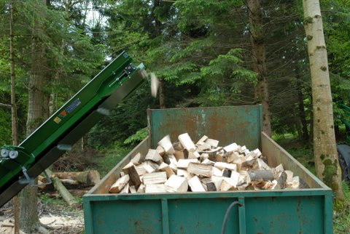
Processing firewood, Birr, Co Offaly

Up to 2010, firewood use was estimated using survey data and industry expert opinion. In 2011, a new approach used the Central Statistics Office (CSO) Household Budget Survey (HBS). It estimates expenditure by households on goods and services. The last survey was in 2004/5. This showed that the average expenditure on firewood per household was €0.26/week. Compound inflation rates were applied to ascertain the expenditure on firewood for the period 2007-2010. The number of households in Ireland was taken from 2006 census data and from preliminary data from the 2011 census. These data were combined with the HBS data to estimate the volume and value of the domestic firewood market in Ireland:

Volume and value of the domestic firewood market in Ireland (2006-2010).

Year | 000 m³ | € million
2006 | 147 | 21.35
2007 | 159 | 23.03
2008 | 171 | 24.83
2009 | 184 | 26.75
2010 | 199 | 28.80

Firewood harvest for 2011 will be estimated using new HBS data. Data are currently being processed and evaluated by the CSO and will be available in early 2012.

Contributed by Eoin O’Driscoll, forestry consultant, compiler of the EUROSTAT Joint Forest Sector Questionnaire (JFSQ) on behalf of FSD

Carbon Corner
Counting carbon
Rules for accounting forest carbon stocks and changes therein for the post 2012 period have been under discussion since the Bali climate change conference back in 2007 – a period of almost 4 years. In that time a new set of proposed rules has emerged, which address the issues that accounting for forest carbon at a national level presents. The current version of the rules text, following the latest round of talks in Panama, is at http://unfccc.int/resource/docs/2011/awg16/eng/crp02r01.pdf.
As part of the negotiation process, data on projected carbon stock change over the period 2013-2020 in pre-1990 forest have been formally submitted by developed country Parties in order to establish a reference level against which changes in forest carbon stocks can be assessed and accounted. Each submission has been independently reviewed – the technical assessment report on Ireland’s submission is at http://unfccc.int/resource/docs/2011/tar/irl01.pdf. If the new rules are agreed then changes in the carbon stocks in Ireland’s pre-1990 forests will be measured against the reference level. In practice what this means is that if harvest exceeds the projection then debits will be accounted at the national level. Likewise, if the level of harvest is less than projected, or if measures are undertaken to enhance carbon stocks, then credits will accrue at the national level.
As it stands, rules for post 1990 forests are likely to remain unchanged, and if so it may enable Ireland to consider a more ambitious greenhouse gas reduction target over the 2013-2020 period. This is because the level of removal of carbon dioxide by post 1990 forests is increasing year on year on year as forests mature and as the forest area expands. By 2020, post 1990 forests will be removing well in excess of 4.5 million tonnes of carbon dioxide annually from the atmosphere - a tonne per capita of the Irish population. It shows that forests, as part of the suite of national emission reduction measures in the building, transport and energy and other sectors, play an important role in the national strategy to reduce the national carbon footprint, currently one of the highest in the EU.
The next UNFCCC negotiation session is in Durban, South Africa at the end of November. Agreement on the forestry rules at that session would be a signifcant achievement and one that should enable most developed countries to take on more ambitious greenhouse gas reduction commitments up to 2020.

New Publications
Harvesting wood for energy Cost-effective woodfuel supply chains in Irish forestry by Pieter Kofman,Tom Kent and Enda Coates. COFORD.
Provides up-to-date information on woodfuel supply chain systems and costings. Order from Government Publications Office email: pubsales@opw.ie.
The United Nations Economic Commission for Europe (UNECE) Timber Committee Market Report for Ireland 2011
Compiled on behalf of Forest Sector Development (FSD), Department of Agriculture, Fisheries and Food by Eoin O’Driscoll, forestry consultant - available at http://live.unece.org/fileadmin/DAM/timber/country-info/Ireland.pdf

Events

Tending and Thinning of Oak Woodlands
26 October 2011 - Cappamurragh Farm House, Cappamurragh, Ballagh, Dundrum, Co. Tipperary

This event is jointly organised by Teagasc, the Forest Service and FSD/COFORD, this National Demonstration will be of great interest to landowners whose broadleaf woodlands are at, or near, the first tending / thinning stage. The event will provide a valuable insight into the management of young oak woodlands to produce quality stems and in optimising the value of the future crop. There are many young woodlands planted in the mid nineties that are now ready for tending /thinning. It is vital that owners have the knowledge and are ready to commence this operation at the right time. This operation can provide a good source of revenue while also increasing the productivity of the broadleaf crop.
The event will demonstrate to participants the optimum time to commence tending and first thinning of Oak. Other important topics include felling licence, harvesting grants, road access, firewood and charcoal production and non-timber products such as fungi.
Participants will be shown the process of marking the trees for tending with identification of potential final crop trees and subsequent marking of stems to be removed including competitors, wolves and diseased stems. The demonstration will also include a visit to a plot that has recently been tended.
Tending and thinning broadleaves are essential operations to ensure the production of valuable hardwood timber optimising returns from your broadleaf forest. This is the first oak thinning event to be held nationwide. It is therefore a great opportunity for oak growers to see and experience best practice for tending and thinning of oak crops.
This event will take place on Wednesday 26 October 2011, at Cappamurragh Farm House, Dundrum, Co Tipperary. Arrive any time between 11am and 12.30 pm. Please note that guided tours will leave every twenty minutes between 11am and 12.30pm and the demonstration will take approximately 2.5 hours.
This is an outdoor event so please bring appropriate footwear and raingear. All are welcome. Event is free.
For further information contact Michael Somers of Teagasc. Phone:
Directions to venue:
Cappamurragh Farm House, Cappamurragh, Ballagh, Co. Tipperary. The Event will be signposted from the Thurles-Tipperary Town road and the Cashel-Dundrum road.

Innovative wood display lights up Electric Picnic
Woodspace – Forest of Light project
The Woodspace – Forest of Light - Yggrassil - project which featured recently at the Electric Picnic event held at Stradbally Hall, Co Laois over three days in September was a collaboration between Meitheal Adhmaid and the Wood Marketing Federation (WMF), with the assistance of Coillte, Glennon Brothers, ESB and FSD/COFORD. The overall objective was to promote wood as a key renewable design material for the 21st century.
The exhibit was designed by the architect Eugene Boyle, in collaboration with Donal Magner and others. It features Douglas fir poles and a lighted sawn timber centre-piece. Over 70,000 people attended the event - many of whom visited the exhibit and display panels.
A display based on the Electric Picnic and other Meitheal Adhmaid exhibits runs from Monday 31 October to Friday 18 November, as part of Innovation Dublin Festival and Design Week, at The Greenbox, Andrew St, Dublin 2.

For further information please contact woodcollective@gmail.com.

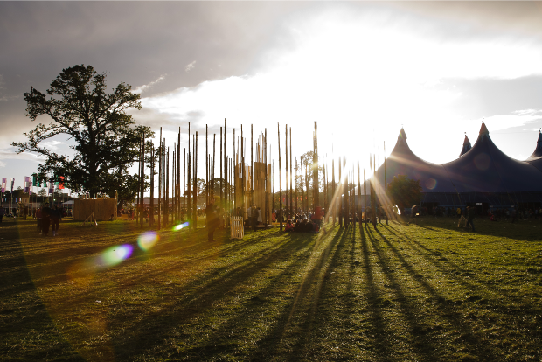
Yggrassil exhibit at Electric Picnic Arts and Music Festival

Arboricultural Association Training Course
26 October 2011 – Botanic Gardens, Glasnevin, Dublin
BS 3998:2010
Tree Work – Recommendations
An overview of the newly revised British Standard
The long awaited revision of BS 3998 was published in December 2010. This very successful series of ‘road show’ events provides a focussed update on the key changes to our industry standard for tree work and Paul Smyth will also introduce the new ARB Approved Contractor Scheme
Course Tutors: Dominic Scanlon, Aspect Tree Consultancy
Paul Smyth, Arboricultural Association
Course Programme: 10.00am – 16.00pm
- Planning tree work operations
- Scheduling of tree work
- Management of rooting environment
- Pruning and related work
- Tree support systems
- Changes to the AA’s Arb Approved Contractor Scheme
Fee: €65 per person
Includes tea & coffee
Book through www.trees.org.uk

RDS - Forest Service - Irish Forestry Annual Awards 2011
Farmleigh House, Dublin - 18 October 2011

The annual RDS - Forest Service Irish Forestry Awards presentation took place in Farmleigh House, Dublin. Minister of State at the Department of Agriculture, Food and the Marine with special responsibility for Forestry, Mr Shane McEntee, TD. was in attendance to present these prestigious Awards.
There are two award categories. The Farm Forestry Award is presented to farmers or co-operatives that have excelled in forestry for commercial use. The Bio-Diverse Forestry/Woodlands Award is given to an individual or organisation that has helped develop or expand a new or existing forest habitat through natural and environmentally sensitive methods.
The winner of this year’s Farm Forestry Award, which included a cheque for €2,000, a perpetual trophy and an RDS Silver Medal, was Mr Michael Murphy from Clonmel, Co. Tipperary. In the same category, this year’s Merit Award and a cheque for €1,000 was presented to Mr Victor Dunne from Gorey, Co. Wexford.
A best New Entrant Award was made in each category this year in recognition of the increasing number of new people who become involved in forestry each year. The best New Entrant in the Farm Forestry Category and recipient of a RDS Certificate of Merit and a cheque for €500 was Mr Ross Buchanan from Burt, Co. Donegal.
The Bio-Diverse Forestry/Woodlands Award, which also includes a cheque for €2,000, a perpetual trophy and an RDS Silver Medal, went to Mr Jack Tenison from Castleblayney, Co. Monaghan. Mr Bryan Hennessy from New Ross, Co. Wexford, won the Merit Award and a cheque for €1,000. The best New Entrant in the Bio-Diverse Forestry/Woodlands category and recipient of a RDS Certificate of Merit and a cheque for €500 was the Hyde Family Woodlands of Ballinasloe, Co. Galway.
In addition to the two award categories, a Special Judges’ Award was presented to Mr John Jackson, Co. Donegal. Mr Jackson has made a very significant contribution to farm forestry both on a national basis and, in particular, in his native Donegal since he first became involved in forestry in the early 1990s. Mr Jackson has hosted many field days and educational events on his farm, welcoming everyone from those involved in commercial forestry to local school groups. Mr Jackson was the IFA forestry representative for Donegal and Chairman of the IFA National Forestry Group from 2003 to 2007 also.
The RDS – Forest Service Irish Forestry Awards seek to promote excellence in timber production for commercial use and encourage diverse forest habitats for ecological benefit. As well as recognising and rewarding forest owners who are employing the basic principles of sustainable forest management on their properties, the Awards also promote the forestry industry in Ireland, the challenges it is facing, and the measures it is undertaking to provide for commercial timber production while maintaining a rich ecosystem to pass on to future generations.
The RDS has been championing and supporting the Irish forestry industry since 1740, when the Society first granted premiums which resulted in the planting of 55 million trees over 40 years. These Awards are another example of the Society’s commitment to agricultural advancement in Ireland.

RDS – FOREST SERVICE IRISH FORESTRY AWARD WINNERS 2011
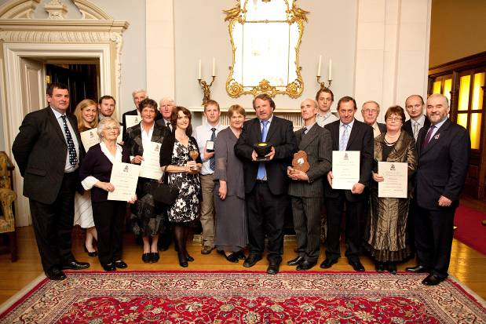

Left to right, Minister of State Mr Shane McEntee TD., Mrs Annie Buchanan, Mrs Anne Hyde, Mr Ross Buchanan, Mr Michael Hyde, Mrs Helen Hennessy, Mr Bryan Hennessy, Mrs Catherine Murphy, Mr Patrick Murphy, Mrs Elizabeth Jackson, Mr John Jackson, Mr Jack Tenison, Mr Daryn Dunne, Mr Victor Dunne, Mr Patrick Lynch, Mrs Margaret Lynch, Mr Seamus Dunne of the Forest Service and RDS president Mr Fonsie Mealy.

For further information please contact:

J.P. Montgomery……………………...Paul Farrelly
The RDS Marketing Department……..RDS Development Executive
01 2407 222…………………………...01 2407 215
jp@rds.ie ……………………………paul.farrelly@rds.ie
www.rds.ie/agriculture

Tree Day- 6 October 2011
Shane McEntee, TD, Minister of State at the Department of Agriculture, Food and the Marine with responsibility for forestry, marked 'Tree Day 2011' with a tree planting ceremony at Castletown National School, Co. Meath.
Noting that the theme of Tree Day 2011 is 'Celebrating our Friend the Tree' to mark this UN International Year of Forests, the Minister of State commented, "Trees are an integral part of our landscape and forest products are a feature of our everyday surroundings so it is helpful for children to have this opportunity on National Tree Day to learn about trees and forests in a practical way." The Minister went on to say "When you plant a tree you don't do it for today. You do it for tomorrow - for your children and their children in turn".
Organised by the Tree Council of Ireland with the support of the Department of Education and Skills, Tree Day is an annual event, the purpose of which is to increase children's awareness of the importance and benefits of trees. Minister of State McEntee added, "I understand that this year's Tree Day campaign has been overhauled and redeveloped by the Tree Council, with the help of their sponsor Tetra Pak. I also note that the campaign is also supported by a number of Tree Council membership organizations which host walks at a number of locations throughout the country".
The Minister of State concluded by thanking the staff and pupils at the School for hosting the tree planting ceremony.
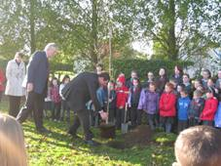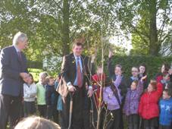
Date Released: 06 October 2011

National Trails Day – 2 October 2011
Shane McEntee TD, Minister of State at the Department of Agriculture, Food and the Marine with responsibility for forestry, highlighted National Trails Day which took place on Sunday, 2nd October 2011, and encouraged people to avail of the opportunity to explore trails and enjoy the activities organised throughout the country.
Jointly highlighting the event with Ms. Michelle O'Neill, MLA, Minister for Agriculture and Rural Development in Northern Ireland, the Minister of State commented that it was an ideal opportunity for people to become aware of, and sample, the benefits of exercise in the natural environment with a variety of trails on offer including walking, cycling, equestrian and water trails.
Minister of State McEntee added, "We are all well aware of the benefits of exercise, especially outdoors in the fresh air, for our physical and mental health. Events have been organised all over the country for National Trails Day and this is a chance to see, and to experience, what is available in your own locality or county. There is a wide range of recreational opportunities on offer so this is an ideal opportunity for people to go out and enjoy the Irish countryside."
National Trails Day is an all-Ireland event organised by Coillte, the Department of Environment, Community and Local Government, the National Trails Office of the Irish Sports Council and Fáilte Ireland along with the Countryside Access & Activities Network in Northern Ireland. The support partners include the Forest Service of the Department of Agriculture and Rural Development in Northern Ireland.
Now in its fourth year, there is a wide variety of events planned all over the country, North and South, with a full listing of events on www.nationaltrailsday.ie.
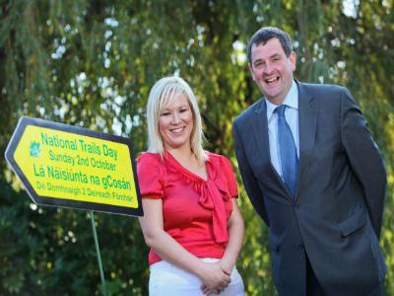
Date Released: 30 September 2011

National Ploughing Championships- 22 September 2011

During his visit to the National Ploughing Championships in Athy, Co. Kildare, Shane McEntee TD, Minister of State at the Department of Agriculture, Food and the Marine, with responsibility for Forestry, announced a series of forestry promotional events to be held in Co. Clare from 2nd October to 19th October 2011.
In announcing the promotional campaign entitled "Focus on Forestry, Clare - 2011", Minister of State McEntee said, "Focus on Forestry, Clare - 2011 is a series of events designed to highlight the many benefits of forestry and to raise awareness among forest owners of the benefits of planting native trees, appropriate management of forests and marketing of their timber resource, including its value as a sustainable and renewable energy source. There are also events to encourage individuals, families and schools to see and appreciate the recreational and environmental value of our forests".
The Minister of State thanked all of the organisations involved for their contributions and co-operation in making the forestry promotional events possible and he thanked, in particular, Teagasc's Forestry Development Department for its role in organising and promoting the event.
Minister of State McEntee reminded people that forestry information was also available during the National Ploughing Championships from the Department's Forestry stand located at Row P, stand no. 582. Inviting people to visit the stand to obtain information on the Department's forestry schemes in general and advice on the prevention of forest fires, Minister McEntee commented, "I am looking forward, during my visit to the National Ploughing Championships, to meeting people engaged in the forestry sector. While the Department's main stand will be located in Row G, stand no. 200, the Forest Service of my Department will be located among the forestry industry marquees and displays in Row P and I encourage people to visit the stand at P582 to learn more about forestry and its benefits".
Date Released: 22 September 2011

Research Programme

CLIMADAPT UPDATE

Matching well suited tree species to different site types is the first and most fundamental step of sustainable forest management. Ecological Site Classification (ESC) has in the past provided support on ecological suitability analysis and site yield estimation for forest managers in other countries, and more recently has been used to consider changes in suitability and yield resulting from different climate change scenario projections.
The COFORD funded CLIMADAPT project will shortly release a web based decision support system for site/species (30 major existing and potential forest species) suitability analysis in Ireland that will also climate change proof species choice. The objective is to provide decision support to forest managers and policy makers, using soil and climatic information for Ireland that can be used to assess changes in species suitability and yield resulting from different climate scenarios. Future projections suggest that both medium-low and medium-high scenarios for green house gas emissions will induce warmer, drier summers in the south and east of Ireland. This may affect growth and yield for drought sensitive species such as spruce, beech and ash. This will allow wide access, use and application to practitioners in Ireland; providing information and knowledge to underpin sustainable forest management in a century of global climate change and increased woodland expansion.
The new web application will be launched on the COFORD website followed by user training workshops in November/December this year.

Contributed by Dr Kevin Black, programme leader CoFoRD national research programme on forests and climate change

Grass seeding clearfelled blanket peats–

a novel solution to mitigate Phosphorus release after forest harvesting?

During the first two years after forest harvesting, the in-situ biodegradation of tree branches, roots and needles can lead to substantial phosphorus (P) releases to receiving waters, and a reduction of in-situ P availability for reforestation. The P releases could be taken up and stored by in-situ vegetation, such as native grasses, if they are present. As it takes up to four years for natural revegetation to sufficiently develop after harvesting in clearfelled blanket peatlands, little of the P released during the two-year post-harvesting period will be assimilated in-situ before it enters the receiving waters. One rational P mitigation approach – examined in this study - is to seed the clearfelled area with fast-growing native grasses during the first year after harvesting so that they can take up the P during the high P release periods.
In this Burrishoole, Co Mayo experimental field study on the growth of a variety of native grasses on clearfelled blanket peat, Holcus lanatus (Yorkshire fog) and Agrostis capillaris (bent grass) were the two most successful grass species. These were sown on a 50:50 basis (with the total seeding rate of 36 kg ha⁻¹.) in three experimental plots (100, 360 and 660 m²) immediately after harvesting; after one year, the P contents in the above-ground grasses were 2.83, 0.65 and 3.07 kg P ha⁻¹, respectively, which were significantly higher than 0.02 kg P ha⁻¹ in unseeded control plots, and the water extractable soil pore phosphorus (WEP) contents in the three experimental plots were 8.44, 9.83 and 6.04 mg (kg dry soil)⁻¹, respectively, which were significantly lower than 25.72 mg (kg dry soil) ⁻¹ in the control plots. The results indicate that grass seeding of the peatland immediately after harvesting: (i) can quickly immobilize significant amounts of P in-situ making it available for reforestation, and (ii) warrants additional research as a new Best Management Practice following harvesting in blanket peatland forests to mitigate P release.

Contributed by Dr Liwen Xiao, Dr Michael Rodgers, Connie O’Driscoll, Mark O’Connor and Zaki-ul-Zaman Asam (NUIG)
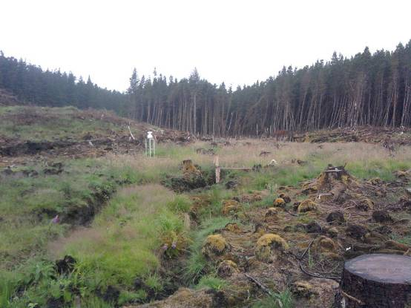
Control site
One year after seeding

Economic contribution of forest sector 2010
Economic contribution from forest products sector reached €2.2 bn in 2010

Research carried in UCD and UCC by the CoFoRD-funded FORECON project team has shown that in 2010 direct output in the forestry sector (i.e. the growing sector; excluding the processing sector) was €378 million. For every one million euro in expenditure in the sector a further €780,000 in expenditure was generated in the rest of the economy. Hence, the overall value of the forestry sector to the Irish economy was €673 million. Direct employment in forestry was 3130 while the total employment (direct and induced) supported by the forest sector was estimated to be 5530.
Direct output in the processing sector (i.e. panel board mills, sawmills and other wood products) was €1.3 bn. Direct employment in the sector was 3910. Accounting for the induced and indirect effects, the total employment supported was estimated to be 6410. The total value (direct and indirect) to the economy of the processing sector of the forest industry was €2.2 bn, over three times the forestry sector contribution of €673 million.

Contributed by Dr Áine Ní Dhubháin (UCD) and Dr Richard Moloney (UCC)

National and international news

Technology Collaboration
Peatlands, characteristic of Ireland, have a highecological
Joint Research Centre - The European Forest Fire Information System (EFFIS)
The JRC is the European Commission’s in-house science service. It is independent of any national, private or industry interest and provides sound and relevant scientific input to European policy making. Across Europe, the JRC works with a large number of public and private organisations, research centres, universities, regulatory bodies, local authorities, industrial associations and companies within networks.
The JRC-Ireland collaboration document was updated in August. It includes a short piece on the EFFIS / Forest Service collaboration that took place earlier this year as well as other interesting information.
The European Forest Fire Information System (EFFIS) is an integrated web-based spatial information system which provides access to real-time forest fire information across Europe. The system was used to monitor the extent and severity of the wildland fires that took place in Ireland in April and May 2011. The post-fire analysis that was carried out by the EFFIS team estimated that the total burnt area was over 10,000 ha, of which approximately 8% was forest land. This data has since been used to support the Irish Forest Service, Department of Agriculture, Fisheries and Food, for their post-fire assessment and planning of forest areas in the affected regions.

For further information please follow the link:
http://ec.europa.eu/dgs/jrc/downloads/jrc_country_leaflet_ie_en.pdf

EUROSTAT Joint Forest Sector Questionnaire (JFSQ) undertaken by drima marketing on behalf of the Department of Agriculture, Food and the Marine.

