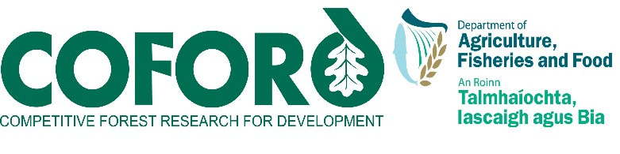Forestry and Wood Update
December 2011
Volume 11 Number 5
CONTENTS
Information and support services 2
Carbon Corner 2
REFIT III gets the green light from Brussels 4

Events 5
FUTURE TREES - from the nursery to Urban Canopy, National Botanic Gardens, Glasnevin, Dublin 26 January 2012 5

Research Programme 6
Land-use and forest ecosystems 6

National and international news 8
Minister of State McEntee addresses the new COFORD Councill 8

COFORD
Department of Agriculture, Food and the Marine
Agriculture House
Kildare Street
Dublin 2
Ireland
Tel: +353 - 1 - 6072000
Email: info@coford.ie
Web: www.coford.ie
COFORD’s activities are funded by the Irish Government

PLEASE CIRCULATE THIS NEWSLETTER TO YOUR COLLEAGUES AND OTHER INTERESTED PARTIES

TO SUBSCRIBE TO THE NEWSLETTER, CLICK HERE

Newsletter compiled and edited by Orla Cashen, John Fennessy and Eugene Hendrick, Forest Sector Development Division (FSD), DAFM.

For further information please contact orla.cashen@agriculture .gov.ie

Information and support services

Carbon Corner

Outcome on forestry rules from Durban climate conference
After four years of protracted negotiations a new set of forest carbon accounting rules for developed countries for the post 2012 period were agreed at the recently concluded Durban climate change conference. The rules will apply under a second commitment period of the Kyoto Protocol, which will run from 2013 to the end of 2017 or 2020, whichever is agreed in the coming year.
A summary of the main features of the new rules follows:

- Article 3.3 ARD Treatment of afforestation, reforestation and deforestation since 1990 – Article 3.3 will be as in first commitment period, mandatory with no cap on credits or debits.

- Debit/credit rule The debit/credit rule that allowed Parties to only account for debits up to the level of credits already received for Under Article 3.3 – is not included in the new rules.
- Article 3.4 Forest Management Accounting for pre-1990 forests under Article 3.4 Forest Management, now becomes mandatory on the basis of a projected reference level approach for most Parties. The reference level is the estimated net carbon stock change over the period to 2020, based on business-as-usual harvest and growth levels in all managed pre-1990 forests. All reference levels were subject to an independent technical assessment, using pre-defined criteria.
Potential credits arising from Forest Management are capped at 3.5% of base year emissions (excluding LULUCF), or about 1.95 million tonnes of carbon dioxide per year in Ireland’s case. If projected harvest levels and assumed growth patterns over the period to 2020 are as envisaged in Ireland’s reference level then no credits are likely to arise. On the debit side the EU’s position going into the negotiations was that there should also be a cap on debits, but up to twice the level of credits. In the event the new rules do not limit debits. All other things being equal therefore, increased levels of harvest in pre-1990 forests over and above those in the reference level will result in debits at the national level.

- Compensation rule The compensation rule – whereby debits from deforestation could be compensated by credits from Forest Management has also been removed form the new rules. The EU had favoured retention of the rule, as implicit in the final part of para 14 of the March 2011 Council Conclusions³.

- Harvested wood products can now be accounted on the basis of when emissions occur, rather than the previous assumption of instantaneous oxidation at harvest. This better reflects the contribution of the harvested wood products pool to climate change mitigation and also the IPCC conclusions that the mitigation benefits of the land use, land-use change and forestry (LULUCF) sector is a combination of sequestration, materials substitution and fossil fuel replacement. At a policy level it provides an incentive to balance harvest and sequestration, as emissions from the harvested wood products pool need to be offset by new products entering the pool, otherwise debits will accrue. The new rule also provides a greater balance between the use of wood for energy generation and in solid wood products such as sawn wood and panels.
Under the new rules however, wood products arising from deforestation will continue to be instantly oxidised. This treatment was retained due to fears that delaying emissions from harvest could provide an incentive for deforestation. There is no evidence to support this contention, and in most cases, due to conversion and other losses along the production chain, less than 40% of roundwood harvest ends up as solid wood products.
- Natural disturbances Another major achievement in the new rules is a definition of natural disturbances and how Parties can deal with greenhouse gas emissions arising from natural disturbances caused by wildfires, insect damage, windthrow and other non-anthropogenic causes. Parties have to submit information on their background level of natural disturbances by 2015 if they wish to have access to the provision. The provision applies to both pre- and post-1990 forest.

- Flexible land use A new rule, proposed by New Zealand, to enable forest dating from the period 1960-1990 to be converted to other land uses without triggering deforestation was agreed. The proviso is that an equivalent area of land is afforested which will replace the carbon stocks over a specified period of time.

- Drainage and rewetting From the Irish perspective this new voluntary activity on organic soils is of potential interest. It applies to emissions and removals of greenhouse gases arising from the activity compared with a 1990 baseline.

- Cropland and grazing land management The voluntary nature of these activities has been retained. However, paragraph 5 of the decision text calls on the Subsidiary Body for Scientific and Technological Advice (SBSTA), to initiate a programme of work to examine a ways to include a wider range of activities such as cropland and grazing land management for the period beyond 2015.

- Further SBSTA work There are four other requests in the decision for the SBSTA to carry out work and to report to COP 9 at the end of 2013.

Following the Durban agreement on the LULUCF rules, the European Commission is due to begin interservice consultations on its proposed Communication on LULUCF and the Effort Sharing Decision. Discussions with Member States are likely to begin in early March.

Decisions and future processes on REDD+ (Reducing Emissions from Deforestation and forest Degradation, conserve and enhance forest carbon stocks and sustainably manage forests) also emanated form Durban and these will be covered in a future Carbon Corner.

REFIT III gets the green light from Brussels

The Minister for Communications, Energy and Natural Resources, Mr Pat Rabbitte TD announced on the 18 November that he had received the formal notification from the European Commission in relation to the State Aids submission for Renewable Energy Feed-in Tariff for biomass technologies (REFIT III) and stated that he would be seeking Government approval to formally open the scheme within a couple of weeks.
The announcement paves the way for the connection of an additional 310 MW of renewable energy to the grid. The technologies supported will include Combined Heat and Power (CHP) from Anaerobic Digestion and Biomass as well as Biomass Combustion including the co-firing of biomass in peat powered stations.
One of the main feedstocks for Biomass CHP is forest-based biomass comprising sawmill residues and thinnings from forest plantations. There is potential to augment this supply with harvesting residues.
The new tariffs will range from 8.5 to 15 cent per kWh in guaranteed support prices, depending on the technology deployed.

Update on national catalogue of seed stands – new stands selected in 2011

Seed stands play a pivotal role in the development of our future forest since they provide the reproductive material from which the new plants are produced and are used to establish future forests. Seed stand selection is an ongoing process, as mature stands are felled new replacement stands are located and if considered suitable are registered in the National Catalogue of Seed Stands. In 2011, approximately 260 ha of seed stands were selected, registered and added to the National Catalogue. These include nine species in Table 1.

Table 1: Additional area of seed stand selected and registered during the period 1st January to 31st December 2011
Species | Area  ha
Alder | 1.6
Ash | 6.2
Beech | 3.3
Lodgepole pine | 45.3
Sessile oak | 14.4
Norway spruce | 89.3
Sitka spruce | 88.1
Scots pine | 10.8
Wild cherry | 0.8

The quest for suitable stands is a continuing process and best stands of most species are constantly required. If you are a forest owner of a stand of a species which you consider may have potential as a registered seed stand – adequate size (at least 0.5 ha in extent and of superior productivity and quality) COFORD would be delighted to hear from you. If you have any questions about the suitability of a stand we are always available to go on site and advice you accordingly. The service is totally free and without any obligation. Selected seed stands are to be found across the entire forestry sector in Ireland and include the private forestry sector, the public sector (Coillte), the National Parks & Wildlife Service estate and a number of private forests.
For further information contact John Fennessy at: john.fennessy@agriculture.gov.ie or phone 01-6072944.

Events

: FUTURE TREES - from the nursery to Urban Canopy

Conference Centre, National Botanic Gardens, Glasnevin, Dublin 26th January 2012
This one day seminar focuses on how improved guidance is changing how trees are produced, planted, and successfully established in the urban environment. Key to this will be the increasing role of Arboriculturists in cooperation with related professionals in nursery production, landscaping, landscape architecture, engineering, and planning.
SPEAKERS
Keith Sacre, of Barcham Trees, is the driving force behind the forthcoming BS 8545 dealing with the production and establishment of young trees.
Martin Kelly, Land Planning Director of Capita Symonds, is the Founder and Chair of the Trees Design Action Group, a network of diverse stakeholders including public and private sector groups, promoting the benefits of trees
in the built up environment. (www.tdag.org.uk)
This seminar will be of special interest to consultant and contracting Arboriculturists, Landscape Architects and Contractors, Park Superintendents, those in the Tree Production and Supply Industry, Architects, Environmental Engineers, and Planners.
PROGRAMME
10am – 10.30: Coffee & Registration
10.30: Welcome address/Introduction (Roy Goodwin)
10.30 - 12.00 & 1pm-2pm:
Keith Sacre
• Nursery production and transplanting success, and the impact of plant health testing
• Problems associated with transplanting young trees successfully into the urban environment, and how these overlap across professional disciplines
• Update on the development and purpose of the proposed new British Standard BS 8545 Young Trees: From Nursery through to Independence in the Landscape’.
2pm – 2.15pm Coffee & Scones
2.15 – 3.30pm:
Martin Kelly
• Trees Design Action Group – principles, aims, and success so far in the UK.
3.30-4pm: Questions & End.
Cost: €65.00
The Arboricultural Association – Irish Branch
Contact Details:
Mr Felim Sheridan, 94 Ballybawn Cottages, Enniskerry, County Wicklow, Ireland
Phone: +353 (0) 1 2742011
E-mail: arborist@eircom.net Website: www.trees.org.uk

Land-use and forest ecosystems
“INTEGRAL -Future-oriented integrated management of European forest landscapes” is the title of a new European forestry research project which started in November 2011. The focus is on forest policy, land-use and sustainable forest management. Prof. Maarten Nieuwenhuis of UCD Forestry is the lead researcher in Ireland. It is a large scale project with 20 partners, a total budget of nearly 9M€, running for four years. The project is part (75%) funded by the Cooperation programme of the European Commission’s seventh framework programme for research (FP7) under the environment theme (ENV.2011.2.1.6-1 Land-use and European forest ecosystems). The coordinator of the project is Ljusk Ola Eriksson of the Swedish University of Agricultural Sciences.
The stimulus for the project comes from difficulties in implementing land-use policies in Europe related to forestry. The environmental and socio-economic roles of European forests are well documented and acknowledged in policy documents of both the European Union and its member states, including Ireland. But, there are problems with forest-related land-use policies, the main issue being mismatches between the policies and their implementation at the landscape level. Hence, there is a need to improve existing policy and management approaches capable of delivering a better balance between multiple and conflicting demands for forest goods and services. Reducing the degree of mismatches and providing a new policy and management approach that is sensitive to ecological, socioeconomic and political issues of are the main objectives of the INTEGRAL project.
The research project has three phases: i) diagnostic analysis of the current situation; ii) participatory development and evaluation of scenarios & iii) problem-solving oriented back-casting for policy development and evaluation.
The research design will be applied in a total of 20 landscapes in Europe and two of these will be in Ireland: Counties Wicklow and north Cork. The study will include landscapes that differ in key characteristics, such as ownership, the importance of forestry and forest-based industries and the priorities of allocation and management of new and existing forest lands. The involvement of national and local stakeholder groups all the way through the project will play a decisive role in the project.
The most important long term impact of INTEGRAL in Ireland and other partner countries is the knowledge and competence base for integrating international, national and local levels in participatory decision and planning processes. This includes the development of manuals for how to conduct such processes, methods for utilizing quantitative decision support tools in the participatory process, and the establishment of a body of knowledge among those participating in the extensive case studies. Thus, the consistency of implemented forest policies can be enhanced.
The INTEGRAL project will address deficiencies in current processes of formulation and implementation of forest and forest-related land-use policies. The research design will be applied to sustainable land-use management in different parts of Europe, in a series of case studies, each focusing on one to three policy-relevant landscapes in a single country. This will yield tangible results related to the development of coherent policy and economic frameworks, and consistent policy instruments and forest management strategies for integrated forest management at landscape level in Europe.
UCD Forestry, with support from Coillte will participate in two key areas of research: Decision support systems for integrated forest management and Policy analysis and foresight for integrated forest management. For more information about the project contact Maarten Nieuwenhuis (@ucd.ie).
Charles Harper, UCD Forestry.
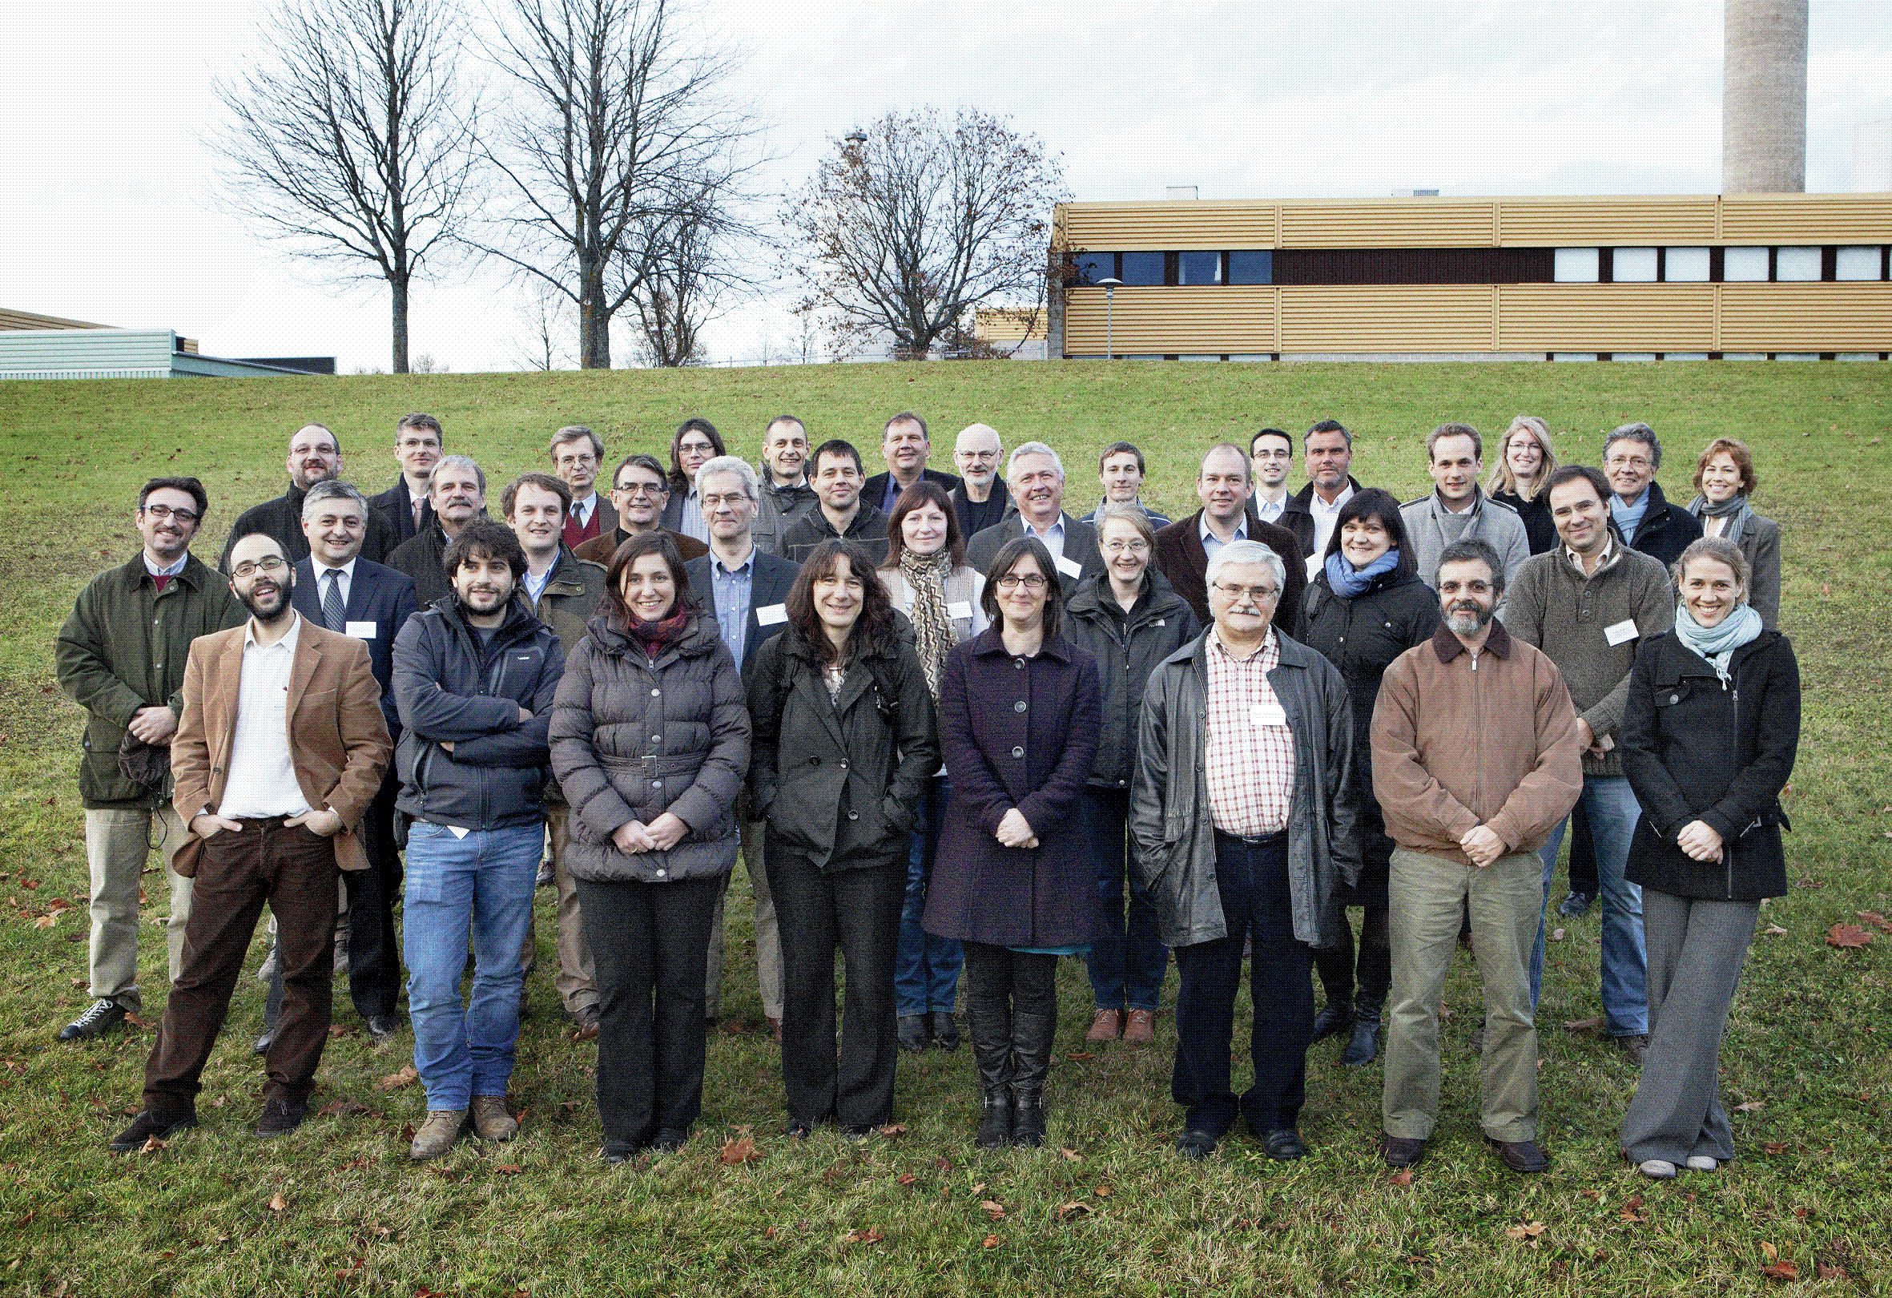
Participants at the kick-off meeting of INTEGRAL pause for a group photo at the Swedish University of Agricultural Sciences, Uppsala.

National and international news

Minister of State Shane McEntee TD welcomes new COFORD Council

and addresses its first meeting
Press Release 16th December 2011
Addressing the first meeting of the new COFORD Council, Shane McEntee TD, Minister of State at the Department of Agriculture, Food and the Marine with responsibility for forestry stressed the importance of Forestry Research and Development for the continued development of the sector.
Noting that the rationalisation of state agencies over the last number of years had resulted in the executive functions of the National Council for Forest Research and Development (COFORD) now being undertaken within his Department, he added that The re-appointment of the COFORD Council is recognition of the contribution the Council itself has made to the R&D process over the years and can continue to make.
The purpose of the Council is to provide advice to the Department on the research and development needs of the forestry industry. As part of this process, the Council will contribute to the development of a Forest Strategic Research Agenda which, in turn, will enhance and strengthen the Department’s overall research strategy and ensure that there is consistency of approach among the Department’s three competitive research funding programmes covering agriculture, food and forestry. The Council will also continue to contribute to the development of the forest sector. The Minister of State commented, One aspect of this development role is the identification of opportunities and information gaps which need to be addressed. I know, for example, that the outgoing Council did a lot of work forecasting roundwood supply and demand culminating in the publication of an ‘All Ireland Roundwood Production Forecast 2011-2028’ and the related roundwood demand report.
The Minister of State added that the composition of COFORD Council, which includes representation from State bodies, forestry grower representative groups and private forestry companies, has been one of its strengths over the years and commented that Such unity of purpose is welcome and indeed essential if we are to work together to develop the forestry sector.
Noting the importance of R&D, as underlined in Food Harvest 2020, Minister of State McEntee thanked the members for agreeing to service on the Council and wished the Council, under the Chairmanship of Mr. Michael Lynn, well in their endeavours. He also thanked the outgoing Council for the work it had undertaken.
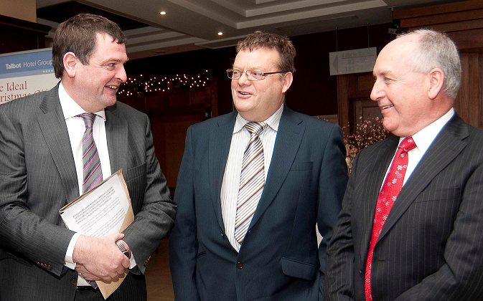
Minister of State, Shane McEntee TD meets members of the new COFORD Council.
Standing from Left to Right: Minister of State Shane McEntee TD, Pat Hennessy (Council Member),
Michael Lynn (Chairman).

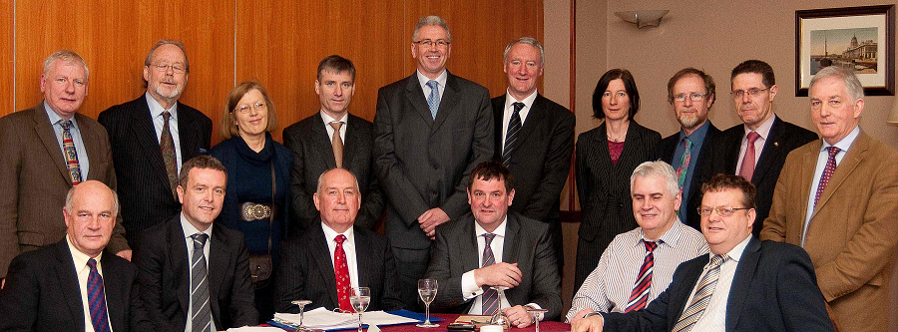

Minister of State, Shane McEntee TD addresses the new COFORD Council.
Standing from Left to Right: John Phelan, John McCarthy, Orla Cashen, Gerard Murphy, Donal Whelan, Eugene Hendrick, Nuala NiFhlatharta, Pearse Buckley, Richard Howell, John Fennessy. Sitting from Left to Right: William Fitzgerald, Mike Glennon, Michael Lynn, Minister of State Shane McEntee TD, John Joe O’Boyle, Pat Hennessy.

Ireland’s submission to the

State of the World’s Forest Genetic Resources

Genetic resources, including forest genetic resources, are among the most valuable assets that a country possesses. The Food and Agriculture Organization of the United Nations (FAO) has for many decades acknowledged the importance of forest genetic resources. In 1967, an FAO Conference recognized that forest genetic diversity was increasingly being lost and requested the establishment of the Panel of Experts on Forest Genetic Resources (Forest Gene Panel), to help plan and coordinate FAO's efforts to manage genetic resources of forest trees. Recognizing the importance of forest genetic resources and the necessity for their good management, the Committee on Forestry (COFO), at its Nineteenth Session, in March 2009, supported the recommendation of the Commission on Genetic Resources for Food and Agriculture and the FAO Panel of Experts on Forest Genetic Resources that FAO prepare a report on The State of World Forest Genetic Resources, to be available in 2013, which would serve as a reference for action at the national, regional and global levels.
In Ireland COFORD/DAFM is coordinating the preparation of the report. The committee which drafted the outline strategy for the publication of Sustaining and Developing Ireland’s Forest Genetic Resources was re-activated to undertake this task. The group held its first meeting in Agriculture House in late March, followed by a number of follow up meetings throughout the year. The final draft is currently being updated and it will be finalized and formally submitted to FAO by early January 2012.
COFORD would like to thank the participants who gave of their time and expertise in contributing to the completion of this important report.
For further information contact John Fennessy at: john.fennessy@agriculture.gov.ie or phone 01-6072944

The detailed decision text is available at: http://unfccc.int/files/meetings/durban_nov_2011/decisions/application/pdf/awgkp_lulucf.pdf Please address any further enquiries to orla.cashen@agriculture.gov.ie.
The Technical Assessment Report of Ireland’s Forest Management Reference Level is available at: http://unfccc.int/resource/docs/2011/tar/irl01.pdf
,See paragraph 14 of the EU Environment Council conclusions at: http://www.consilium.europa.eu/uedocs/cms_data/docs/pressdata/en/envir/119875.pdf
See http://www.dcenr.gov.ie/Press+Releases/Renewable+Energy+Feed-in+Tariff+for+biomass+technologies+%28REFIT+3%29.htm

