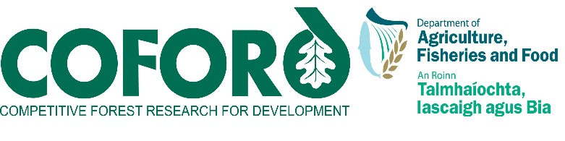
Forestry and Wood Update…..May 2012 …..Volume 12 Number 1
CONTENTS
Information and support services 2
COFORD Council sets up new R&D groups.. 2
Carbon Corner 2
Forest Fungi in Ireland by Louis Smith and Paul Dowling - second edition………………………………3
Forest Genetic Resources in Ireland 3
Deposition and biogeochemical cycling in forest ecosystems 3

Can mixed species stands enhance arthropod diversity in plantation forests? 4
Apps - Wood Species Guide 4

Events 5
Wood for all seasons 5
Biodiversity in forest ecosystems and landscapes 6

National and international news 7
EC forestry and climate change proposal issued 7
European Forests - Central to the World We Live in 7
The future is looking greener for Ireland 7

COFORD
Department of Agriculture, Food and the Marine
Agriculture House
Kildare Street
Dublin 2
Ireland
Tel: +353 - 1 - 6072000
Email: info@coford.ie
Web: www.coford.ie
COFORD’s activities are funded by the Irish Government
PLEASE CIRCULATE THIS NEWSLETTER TO YOUR COLLEAGUES AND OTHER INTERESTED PARTIES

TO SUBSCRIBE TO THE NEWSLETTER, CLICK HERE

Newsletter compiled and edited by Orla Cashen, John Fennessy and Eugene Hendrick, Forest Sector Development Division, DAFF.

For further information please contact orla.cashen@agriculture .gov.ie

Forest Sector Development Division
Department of Agriculture, Food and the Marine
Agriculture House
Kildare Street
Dublin 2
Ireland
Tel: +353 - 1 - 6072000
Email: info@coford.ie
Web: www.coford.ie

PLEASE CIRCULATE THIS NEWSLETTER TO YOUR COLLEAGUES AND OTHER INTERESTED PARTIES

TO SUBSCRIBE TO THE NEWSLETTER, CLICK HERE

Newsletter compiled and edited by Orla Cashen, Pat Farrington and Eugene Hendrick, Forest Sector Development Division (FSD), DAFM.

For further information please contact orla.cashen@agriculture .gov.ie

.
.
.
.
.
.
.
.
.
.
.
.
.
.
.

Information and support services

COFORD Council sets up new R&D groups

At its meeting in February the COFORD Council agreed to set up groups to develop a new forest research strategy, and established three development groups to address: forest management planning, wood mobilisation and forecasting, and examining constraints to afforestation. A further group will update and revise the Forestry 2030 papers. The forest strategy group is seeking submissions (please contact dale.crammond@agriculture.gov.ie). Further details on the objectives and timeframes for the groups can be obtained by contacting Orla Cashen (orla.cashen@agriculture.gov.ie).

Carbon Corner

Update on REDD+ and climate change negotiations under the UNFCCC
Forests in developing countries are under pressure from agricultural expansion, infrastructure development and wood production. Deforestation and forest degradation have become the second largest contributors to worldwide carbon emissions. REDD+ (Reducing Emissions from Deforestation and Degradation) aims to provide a platform to enable financial incentives for developing countries to reduce emissions from deforestation and forest degradation, and should better enable developing countries to improve the protection of forests while fostering sustainable forest management.
Ireland continues to develop its engagement in the REDD+ process and negotiations at the EU level. The upcoming Presidency of the European Council in 2013 will involve increased participation in the negotiations at the United Nations Framework Convention on Climate Change (UNFCCC).
A key element in the negotiations will be progressing international discussions on REDD+ actions, and seeking agreement on how market-based mechanisms should be designed to support measures to halt, reduce and reverse deforestation and forest degradation.

In another development, Ireland’s participation in the European Forest Institute has been further strengthened by the announcement by the Minister of State for Forestry, Shane McEntee, that the Department of Agriculture, Food and the Marine is to become a donor member of the EU REDD Facility which is hosted by the EFI.
EFI’s EU REDD Facility was established in December 2010 to provide effective support to the development and implementation of REDD+ policies in developing countries. It aims to help developing countries build their capacity and improve forest governance for REDD+ through analysis, advice, outreach and training, as well as by facilitating access to and benefit from different ongoing initiatives. The Facility contributes to developing an EU approach to REDD+. It focuses on overcoming the governance challenges related to REDD+ and promoting overall sustainability of REDD+ activities. It seeks to identify and build operational synergies between the REDD+ and the EU Forest Law Enforcement, Governance and Trade (FLEGT) processes so as to increase the effectiveness of both processes, speed up implementation and enhance on-the-ground coordination of EU member states support.
Ireland along with the European Commission and the United Kingdom will benefit from the work of the EU REDD Facility in coordinating outreach programmes and in gaining valuable information from developing countries participating in pilot projects. The contribution by Ireland will enable the EU REDD facility to expand its outreach programmes to developing countries such as Vietnam, which is one of the countries in Ireland’s bilateral aid programme. Closer engagement with the EU REDD Facility process will allow Ireland to play a more effective role in REDD+ negotiations.

For further information please contact pat.farrington@agriculture.gov.ie

Forest Fungi in Ireland by Louis Smith and Paul Dowding

The first edition of the popular COFORD publication Forest Fungi in Ireland by Louis Smith and Paul Dowding, which sold out several months ago, is now available in a second revised edition directly from Forest Sector Development/COFORD or from Government Publications,
Tel: 01 647 6834, Fax: 094 937 8964, email: pubsales@opw.ie.

Forest Genetic Resources in Ireland

Work on a report on Forest Genetic Resources in Ireland to be made to the FAO, has now been published as a COFORD report and is available from Government Publications or can be downloaded from the COFORD web site.

Deposition and biogeochemical cycling in forest ecosystems

Presentations made at the CoFoRD FORFLUX project Advisory Group meeting are available at the web links below.
Ammonia monitoring of forest plots [Julian Aherne] http://people.trentu.ca/jaherne/forflux/20111205%20T2%20forflux.pdf

Time-series analysis [Jim Johnson]
http://people.trentu.ca/jaherne/forflux/20111205%20T3%20trends.pdf

Modelling soil-water percolation [Julian Aherne]
http://people.trentu.ca/jaherne/forflux/20111205%20T4%20forflux.pdf

Ballyhooly–Höglwald comparison [Christian Huber]
http://dx.doi.org/10.1007/s10533-010-9459-9

Nutrient pools [Jim Johnson]
http://people.trentu.ca/jaherne/forflux/20111206%20T5%20pools.pdf

Nutrient input–output budgets [Jim Johnson, Julian Aherne] http://people.trentu.ca/jaherne/forflux/20111206%20T6%20budgets.pdf

Soil base cation weathering rates [Julian Aherne]
http://people.trentu.ca/jaherne/forflux/20111206%20T6w%20forflux.pdf

Dissemination [Thomas Cummins, Julian Aherne]
http://people.trentu.ca/jaherne/forflux/20111206%20T7%20forflux.pdf

Forest Ecology and Management –

Can mixed species stands enhance arthropod diversity in plantation forests?

This article based on COFORD-funded research has been published in a recent edition of Forest Ecology and Management and can be accessed at the link below.
http://www.sciencedirect.com/science?_ob=GatewayURL&_origin=IRSSCONTENT&_method=citationSearch&_piikey=S0378112712000096&_version=1&md5=401fd37894cc5788bb7504f88db18547

Apps - Wood Species Guide
The Wood Species Guide has been created for TRADA by TRADA Technology. It is created primarily for professionals who use wood in architecture and construction, or for furniture. The guide is available at , the species guide enables you to:
• choose the most suitable wood species for your project
• identify physical properties and illustrations for 40 commercial species for free.
The app is available at http://itunes.apple.com/us/app/wood-species-guide/id464128166?mt=8

Events

Wood for all seasons

A major seminar on innovation in wood usage, design and care

This Wood Marketing Federation event will take place on May 11 in Farmleigh House. The event will be opened by Shane McEntee, Minister of State for Forestry and will explore the innovative use of wood and wood products internally and externally. Experts in the fields of architecture, engineering, wood science, timber processing and treatment will address a range of wood use and design issues.

There is no entry charge but booking is essential for logistical and security reasons. Email info@wood.ie or phone or text 086 2607883 providing name, organisation and contact details, before Wed May 9. Please bring seminar brochure to Farmleigh (original or downloaded) from http://www.wood.ie/news-events/major-wood-seminar-in-farmleigh/

Biodiversity in forest ecosystems and landscapes

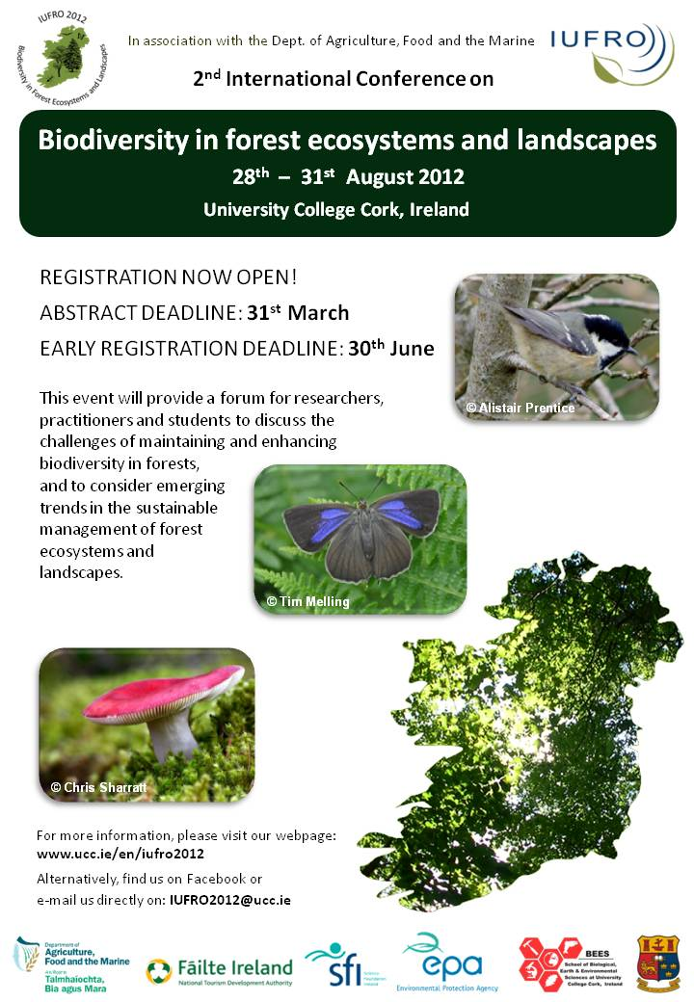

National and international news

EC forestry and climate change proposal issued
The European Commission proposal on accounting rules for greenhouse gas emissions from land use, land-use change and forestry (LULUCF) was issued in March and is available at http://register.consilium.europa.eu/pdf/en/12/st07/st07639.en12.pdf.

‘European Forests: Central to the World We Live in’

EFI has released a new multimedia video on European forests. The video, called ‘European Forests: Central to the World We Live in’, gives an overall picture of Europe’s most versatile ecological infrastructure, tracing a path from south to north and from west to east. . As we tour around Europe, we ask why forests continue to be so important to each region, even in the 21st century.

With this video, we hope to encourage people to work together to overcome the urgent challenges and threats from climate change, and connect research and policy makers to ensure that our forests remain the jewel in the crown of Europe’s environment.

The video is available at: http://www.youtube.com/watch?v=MaKKKdoLc2g
Henna Snellman
Membership Liaison Officer
European Forest Institute
Torikatu 34
80100 Joensuu
Finland
Tel. +358 10 773 4355
Fax: +358 10 773 4377
Email: henna.snellman(at)efi.int
www.efi.int

The Future’s Looking Greener in Ireland
Feb 28 2012 - PEFC International
PEFC International is pleased to announce the endorsement of the Ireland Scheme for Sustainable Forest Management, which has become the first Irish forest certification system to gain global recognition.
“Irish stakeholders have for years been engaged in the development of requirements and criteria for responsible forestry, yet it has been difficult to find consensus between the different interests,” explain William Merivale, Secretary General of PEFC Ireland. “This is why we are so proud to have been able to successfully establish a national standard, drafted in a multi-stakeholder, participatory process, and found to be in compliance with PEFC International’s globally recognized Sustainability Benchmarks.”
National forest certification systems that have developed standards in line with PEFC requirements can apply for endorsement by PEFC International. To achieve endorsement, they need to meet PEFC's Sustainability Benchmarks, which are based on broad societal consensus expressed in international, intergovernmental, multi-stakeholder processes and guidelines. Compliance is confirmed through third-party assessment of national requirements with the international benchmarks, with a global public consultation seeking input from stakeholders worldwide.
The endorsement of the PEFC Irish standard coincides with private Irish forestry coming of age. Over the past 25 years 240,000 hectares of private woodland in the country has been established, and this considerable area of forest, planted in the 1980s and 1990s, is now reaching prime harvesting age. This will provide a huge increase in the private sector’s timber supply.
With this potential increase in supply, the major panel and sawmills have expressed the view that private forest owners need to become certified as quickly as possible, and indicated that they were taking steps towards applying for PEFC certification.
“With more and more companies and public sector organizations requiring certification as evidence for sustainable sourcing, gaining international recognition through PEFC is a much needed development in support of the Irish forest sector,” emphasized Mr. Merivale.

