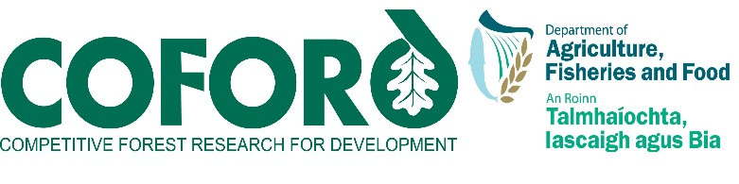
Forestry and Wood Update2012 Volume 12 Number 2
CONTENTS
Information and support services 2

COFORD Council - update on new R&D groups.. 2
New series of COFORD Connects Notes 2
Carbon Corner 3
Stump harvesting 3
Support services 4
Development of international solid biofuels standards 4
Trade in forest-based biomass and other solid biofuels 5

Events 6
Wood Marketing Federation Conference 2012 6
Minister McEntee presents Third Level Student Wood Awards at Farmleigh House 7
Call for entrants for RDS-Forest Service Irish Forestry Awards 9
Biodiversity in Forest Ecosystems and Landscapes 2012 - 2nd International Conference 10
Managing forests for ecosystem services: can spruce forests show the way? 10

National and international news 11
Hen Harrier Final Project Report 11
CSO publishes Environmental indicators report 11
CIP Eco-Innovation has opened its 5th call for proposals on Tuesday 8 May 11
Trees4Future: Your gateway to accessing forest research facilities in Europe 12
Europe's Forests have huge potential for the green bio-economy 13
The Release of CCRP 15 ‘Carbon Restore –The Potential of Restored Irish Peatlands for Carbon Uptake and Storage by the EPA 14

Forest Sector Development Division
Department of Agriculture, Food and the Marine
Agriculture House
Kildare Street
Dublin 2
Ireland
Tel: +353 - 1 - 6072000
Email: info@coford.ie
Web: www.coford.ie

PLEASE CIRCULATE THIS NEWSLETTER TO YOUR COLLEAGUES AND OTHER INTERESTED PARTIES

TO SUBSCRIBE TO THE NEWSLETTER, CLICK HERE

Newsletter compiled and edited by Orla Cashen, Pat Farrington and Eugene Hendrick, Forest Sector Development Division (FSD), DAFM.

For further information please contact orla.cashen@agriculture .gov.ie

Information and support services

COFORD Council - update on new R&D groups

In February the COFORD Council established three development groups to address: forest management planning, wood mobilisation and forecasting, and constraints to afforestation. Further groups were established to develop a new forest research strategy, and to update and revise the Forestry 2030 papers. A brief update of progress in the groups follows.

Forest research strategy group – Chair: John Phelan
References to the policy, legislative and external economic and environmental drivers have now been captured in the Terms of Reference. It was agreed that prioritisation of the research needs should be included. Two consultation papers, a Request for Submissions and a Request for Competencies had been circulated. The overall structure of the report had been agreed, with a planned completion date of December 2012.

Land availability and constraints and incentives to achieving afforestation – Chair: Dr Nuala Ní Fhlatharta
A one day workshop session on afforestation of unenclosed land was held on 28 June, where information relating to land quality was presented and discussed. The agreed time frame for completion of the work was mid 2013, with a progress report in Autumn 2012.

Forest management planning – Chair: Dr Eugene Hendrick
Presentations on the current Forest Service management plan system and on the proposed NI Forest Service system had been made to the group and were circulated. The group had agreed revised terms of reference a specification for technical assistance.

Mobilising wood supply and roundwood production forecasting - Chair: Mike Glennon
The group was of the view that the update cycle for the national roundwood forecast should be every five years. The best way to identify, prioritise and address the issues was for each member to provide a prioritised list, taking into account the work of the Forest Policy Review Group, and relevant reports. Representative organisations had also been circulated.

Updating of Forestry 2030 papers Chair: Donal Whelan
All the authors of the original papers had been contacted. One area that needed to be added was export data. The aim was to update the papers by the end of 2012.

New Series of COFORD Connects Notes

The latest notes in the COFORD Connects series have recently been published:

Reproductive Material
No. 19 Use of exponential nitrogen loading in the nursery to promote nutrient uptake and quality of pedunculate oak seedlings.

Silviculture and Forest Management
No. 20 Dynamic yield models used in Irish forestry
No. 21 Nursing of oak in Ireland

Harvesting, Transport and Forest Machinery
No 28 Establishment of short rotation coppice seen from a harvesting point of view
No 29 Harvesting of short rotation coppice willow
No 30 Storage of short rotation coppice willow fuel

Wood Processing and Product Development
No 17 Gasifier type firewood fuelled boilers (revised in 2012)
No 25 Handling and using wood fuels in a safe manner with regard to carbon monoxide (CO)
No 26 Woodflow and biomass use on the island of Ireland 2009
No 27 Woodflow and biomass use on the island of Ireland 2010

Forestry and the Environment
No 12 Suspended solid yield from forest harvesting on an upland blanket peat
No 13 Phosphorus release from forest harvesting on an upland blanket peat
No 14 A new vision of forest monitoring in Ireland and Europe – the FutMon

The full series of COFORD Connects Notes is available in pdf format on the publications area of the COFORD website, http://www.coford.ie/publications/cofordconnects/

Carbon Corner

The European Commission proposal on accounting rules for greenhouse gas emissions from land use, land-use change and forestry (LULUCF) which was issued in March has been through a number of Council meetings and has been discussed by the Environment Committee of the European Parliament. The original proposal is available at http://register.consilium.europa.eu/pdf/en/12/st07/st07639.en12.pdf.

Stump harvesting

Stump harvesting is gaining in popularity as demand for forest-based biomass for energy use continues to grow. A number of research projects in the area are being undertaken, including work at the Waterford Institute of Technology.

While there is potential to expand the use of stump harvesting caution needs to be exercised so that long-term-site productivity is not impaired; sites with low nutrient levels should be avoided (see http://www.forestry.gov.uk/fr/INFD-7P5J7P). Furthermore, a paper published by Marjo Palviainen and co-workers in Finland highlights the role that stumps have as a nutrient reservoir and in conserving nutrients on site. The paper abstract states: Phosphorus and base cations (K, Ca, and Mg) are released slowly from decomposing Scots pine, Norway spruce and silver birch stumps. The absolute amounts of phosphorus in stumps increased during decomposition. The accumulation of phosphorus is probably mainly due to that decomposer fungi transport phosphorus into stumps from the surrounding soil. By serving as a nutrient sink and long-term nutrient pool with a slow release rate, stumps can potentially contribute to the retention of nutrients and decrease the leaching of nutrients from the forest ecosystem after clear-cutting. The results suggest that when one practises stump harvesting, nutrients are not only removed from the system through harvested biomass, but stump harvesting may also promote the leaching of nutrients.

Support services

For those seeking independent information and advice on wood energy supply chain costings, and on timber product specification, the two COFORD advisory services are available for contact at woodenergy.ie and woodspec.ie. Two short articles by Pieter D. Kofman advisor on wood fuels follow.

Development of international solid biofuels standards

Due to the increased use and trade of solid biofuels (such as wood, straw and olive stones - to name a few) it was decided to start a European standardization process on solid biofuels. The work was carried out in Technical Committee TC335 of CEN – the EU standards organization. Ten years later and 28 standards on all aspects on solid biofuels have been completed and published by CEN and are now also Irish Standards.

However, the work on standards development continues – as the trade of solid biofuels rapidly increases at the global level, and the European Standards on solid biofuels are now forming the basis for the development of worldwide ISO standards, in a new technical committee TC238 Solid Biofuels.

The new TC238 covers a wider range than the CEN work – it also includes Aquatic Biomass (seaweeds, algae) and other materials such as demolition timber and spent palm kernels that had not been included in European standards.

Ireland, through the National Standards Authority of Ireland, was represented in TC335, and is now closely engaging interest has been shown in the ISO TC238, where research done by Tom Kent of Waterford Institute of Technology IT and myself as a project coordinator, and funded under the COFORD programme, on issues such as size distribution of wood chips, has contributed to an improvement of the draft standard ISO EN 17225 on Requirements and Classes. This standard describes, defines and classifies the quality parameters of many different solid biofuels. Part 1 of the standard lists the general requirements; the subsequent six parts of the standard sets out requirements for fuels that are specifically suited for smaller boilers (up to 500 kW). These quality classes when completed can then be used by wood fuel assurance bodies (like the Wood Fuel Quality Assurance Scheme in Ireland), suppliers and specifiers.

Because of all the footwork that was done in CEN, the ISO standards can move ahead much more rapidly. The ISO EN standard on Requirements and Classes is already in the last round of balloting, as are several other standards. Once the last ballot is completed in a half years time, the finishing touches can be completed and the standard will be ready for publication.

The new ISO TC238 will also look at other subjects, which had not been covered by the European TC335, such as the risk of dust explosions, the off gassing of biofuels (which apparently emit carbon monoxide and consume oxygen), the amount of fungi and bacteria spores in the fuels, which also can be a health hazard if the fuels have not been stored properly.

The COFORD Newsletter will contain updates on the progress in the standardization process. A list of published European Standards is available at www.woodenergy.ie, which shortly will list the standards in progress within the ISO working group.

Pieter D. Kofman

Trade in forest-based biomass and other solid biofuels

The demand for solid biofuels, especially wood based ones, is growing very rapidly in Europe. Nearly all European countries have committed themselves to reducing their consumption of fossil fuels by saving energy and replacing fossil fuels by renewable energy generated from many different sources, such as photovoltaic power, wind power, wave energy and geothermal energy, but mainly from solid biofuels and particularly from wood. It has been estimated that if all these plans are carried out by 2020, the EU will have a deficit of woody biomass of somewhere between 50 and 60 million tonnes, which will have to be imported from countries outside the EU.
Many countries in other parts of the world are already gearing up to supply this increased demand. Many new wood pellets plants have been built (or are being built) in for example Canada, US, Brazil, Chile, but there is also a large interest from Asian countries to export their biomass (wood chip from end of rotation rubber trees, shells from palm kernels etc) to Europe.

Exporters are wise to the increasing demands; the time when one could pick up cargoes of cheap biomass are almost over, especially if one wants to sign up for long-term contracts. These long term contracts are necessary for new projects in order to obtain financing from the banks. Only if and when one can show bankable contracts for the supply of fuel, are banks willing to loan money for the construction of the plants.

The import of wood chips into Ireland is regulated under EU Directive 2000/29/EC commonly known as the Plant Health Directive. Forests in Ireland are relatively free from pests and diseases that occur elsewhere in Europe and other parts of the globe. Forests in the rest of the EU are also under threat from specific non-European pests and diseases. For this reason certain species of wood depending on the country of origin are regulated under the Directive and must undergo special phytosanitary treatments. For example the requirement may be kiln-drying to below 20% moisture content or heat treatment to 56 degrees C for a minimum of 30 minutes. Both procedures are expensive. Importers of regulated material are also required to be formally registered. An official plant health certification document may also be required - known as a Phytosanitary Certificate. In Ireland the Forest Service, Department of Agriculture, Food and the Marine is responsible for implementing the plant health regulations for wood and wood products. It is highly advisable to enquire with the Forest Service regarding any plant health entry requirements when planning to import wood chips. Enquiries may be directed by email to forestprotection@agriculture.gov.ie or telephone 01 6072651.

Another issue in importing biomass is the amount that is delivered in one cargo. Especially if one wants to import wood chips one should expect ships of a fairly large size (in excess of 30,000 tonnes of cargo) in order to keep transport costs at an acceptable level. This large amount of wood chips (30,000 tons equal 100,000 loose cubic metres) often needs to be unloaded within 48 hours. The logistics and space requirements are thus very complicated.

Prices that are being quoted at the moment for long-term delivery of large cargoes are in the order of €6.5 to €7 per GJ CIF (cargo, freight and insurance), meaning that that is the price one has to pay for the cargo onboard ship and the costs of unloading, harbour duties, transport to the final customer etc. still have to be added.

Pieter D. Kofman with input Forest Protection Section, Forest Service

Events

Wood Marketing Federation Conference 2012

Minister McEntee launches Wood for All Seasons seminar in Farmleigh -11th May
The Wood Marketing Federation organised a major seminar Wood for all Seasons in Farmleigh on May 11.

Shane McEntee T.D., Minister of State for Forestry, acknowledging the link between the forest and the end user provided the opening address while seven experts made presentations on the importance of wood as a sustainable material for construction and other applications. Minister McEntee said:

I was here in Farmleigh last October to present the RDS-Forest Service Irish Forestry awards, which were made to forest owners and growers who were judged to have achieved excellence in managing their forests. It is great to be back here today to open this particular event, which is focussing on the other end of the forest chain – the use of wood products. The interdependence between both elements of the supply chain is also worth emphasising as timber processors and end-users require an adequate supply of quality raw material.

The keynote speaker was Glenn Howells, Glenn Howells Architects the Birmingham based practice. Howells who is Visiting Professor at Nottingham Trent University has led the practice to win numerous major design competitions and awards for a diverse range of building types including the Savill Garden Visitor Centre, Windsor: Newman University College, Birmingham; and the Market Place Theatre and Arts Centre, Armagh. His talk featured a number of case studies including the Savill buildings.
Ciaran O’Connor the Irish award-winning architect discussed the Green Public Procurement Document for Construction while Gordon Knaggs presented a paper on plywood and panel board products.

Pat Glennon discussed innovative ways to capture markets with homegrown timber. Papers on timber treatment including preservation and coatings were presented by Colin Molloy, Pat McCarthy and Paul Harvey. The seminar was chaired by Richard Lowe, Coillte and is one of a series of wood promotion events organised by the Wood Marketing Federation and supported by the Forest Sector Development Division of the Department of Agriculture, Food and the Marine.
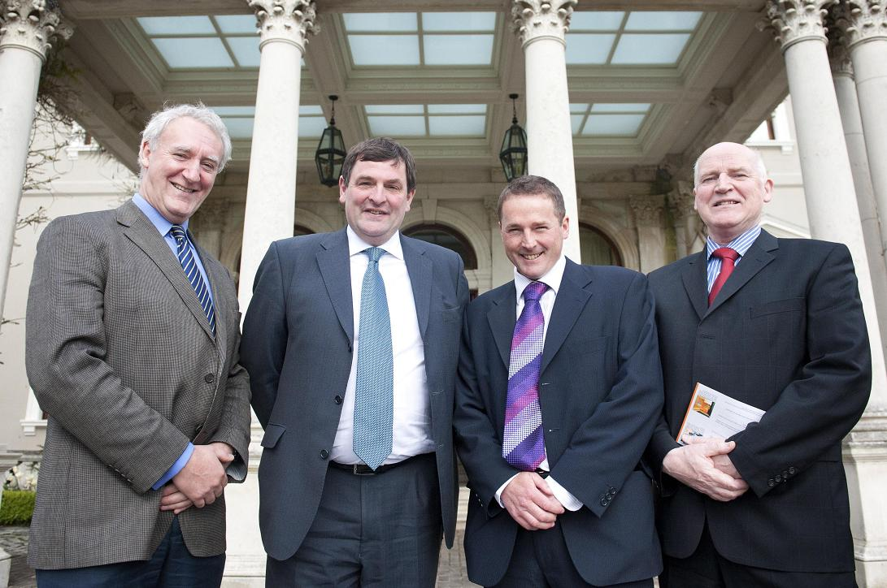
Minister McEntee, who provided the opening address at the Wood for All Seasons seminar in Farmleigh with Dr Eugene Hendrick, Forest Sector Development Division, Department of Agriculture Food and the Marine, Paul Harvey, Chairman Wood Marketing Federation and Donal Magner, Secretary.

Minister McEntee presents Third Level Student Wood Awards at Farmleigh House

Ten universities and institutes of technology took part in the seventh Irish Third Level Student Wood Awards. Judging took place in June in NUI Galway and Queen’s University Belfast after 10 colleges picked their own individual winners to go forward to the national finals in the following three categories:

- Architecture
- Engineering in construction
- Innovative use of timber in design

The awards are supported by the Department of Agriculture, Food and the Marine. The main sponsor is Coillte while additional funding is provided by the Wood Marketing Federation, Wood-ni and the Society of Irish Foresters.

The awards were presented by Shane McEntee, Minister of State at the Department of Agriculture, Food and the Marine, who said

My Department’s involvement in supporting this work stems from the need to grow the use of wood products in home and export markets. As Irish forests grow and mature, the level of wood production is set to double over the coming two decades, so in this light it is important that our future architects, engineers and designers are familiar with wood products and their properties.

Projects were received from students of architecture, engineering and design representing the following colleges:
- Queen’s University Belfast
- University College Dublin
- NUI Galway
- University of Ulster
- Limerick IT
- Cork IT
- National College of Art and Design
- Galway-Mayo IT
- Dublin IT
- Waterford IT

Launched in 2006, the awards are now much sought after by third level students of architecture, engineering and design in Ireland who incorporate wood as an inherent element in their projects. Award winners have gone on to pursue successful careers in wood and related businesses and have exhibited at Irish and international shows. The objective of the awards is to encourage students to explore functional, aesthetic and design aspects of wood and wood products.

The adjudicating panel comprised: Duncan Stewart Architect and Broadcaster, Simon O’Driscoll, O’Driscoll Furniture and Des O’Toole, Coillte; Maurice Brooks, Director Wood-ni acted as facilitator.

University of Ulster (UU) and Queen’s University Belfast (QU) won the top architecture and engineering prizes while the award for best design project went to Letterfrack College.

Fergal Rainey, UU won the architecture award for his project entitled Making Space, Werburgh Street. He designed a house and workshop for a guitar maker and his family in Werburgh Street, Dublin. The key to the project was the student’s response to the existing buildings and his sensitive selection of building materials. He chose Dublin calp (black) limestone and Irish grown spruce to ensure that the building was compatible with the existing streetscape.

The QU project presented by Connor O'Higgins involved the construction of a flexible dome, which has commercial potential. The Queen’s team researched and designed a new method of timber dome construction based on the principles used in the ‘FlexiArch’ system, which allows quick construction of a fully formed dome from flat pack units, with potential for outdoor shows, exhibitions and concerts.

The winning design student, Craig Cox of Letterfrack, Galway-Mayo Institute of Technology, produced a video booth for recording special moments at weddings and parties.

In addition to the award winners, three projects were commended by the judges. Aidan Philpott and Kieran Coakley of Cork Institute of Technology were commended for their project Hardwood lined structural softwood beams using Irish timber. Commendation certificates were presented to Eimear Arthur, University College Dublin, for the project Cultivating continuity and Eoin McCooey of the Dublin Institute of Technology for his project A hygrothermal comparison of cross-laminated timber construction types.

Paul Harvey, chairman WMF, thanked the main sponsor Coillte and Tara Ryan who was the project co-ordinator. He also thanked the Minister and the Department of Agriculture, Food and the Marine along with the Society of Irish Foresters.

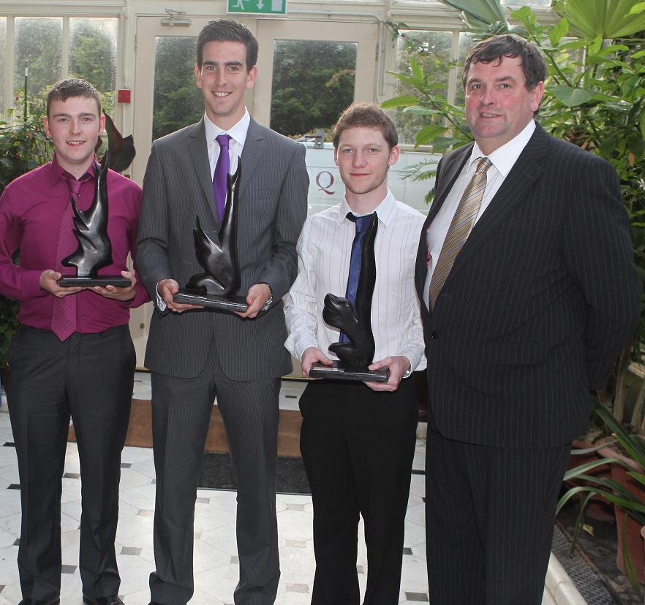
Shane McEntee Minister of State with responsibility for forestry presenting prizes at the Student Wood Awards to Craig Cox, Galway-Mayo Institute of Technology, winner of the Design Award; Fergal Rainey, University of Ulster, architecture, award winner; and Connor O'Higgins, representing the Queen's University team which won the engineering awards.
Further information on the awards is available from the Secretary of the Wood Marketing Federation, Donal Magner (0404 61111, donalmagner@eircom.net)

Call for entrants for RDS-Forest Service Irish Forestry Awards

This year marks the 25th running of the RDS-Forest Service Irish Forestry Awards. The Awards aim to recognise excellence and reward those currently employing the principles of sustainable and commercial forest management on their properties.

There are two awards categories, Farm Forestry and Bio-Diverse Forestry/Woodlands, both of which are based on the need to develop woodlands that can contribute to our economy and, at the same time, support and create habitats for wildlife. Winners receive €2,000, a perpetual trophy and an RDS silver medal. Each runner–up receives a cheque for €1,000. The Best New Entrant in each category also receives €500 and a certificate of merit.

Everyone with woodland is encouraged to enter as all woodlands, large or small, are of merit. All short-listed entries will be visited by the judges in the coming months. Having the judges visit the woodlands is one of the great benefits of entering the awards, as they are experienced foresters and can advise in the development of woodlands.

If you require any additional information please contact the RDS Agriculture Department on 01 240 7215 or email at forestry@rds.ie. The closing date for entries is August 3, 2012.

The RDS-Forest Service Irish Forestry Awards are funded by the Irish Government under the National Development Plan 2007-2013.

Biodiversity in Forest Ecosystems and Landscapes

2nd International Conference - University College Cork 28 – 31 August 2012

This is a reminder of the extended deadline for early registration discount for this event.
DEADLINE FOR EARLY REGISTRATION DISCOUNT – 20th July 2012
This conference will provide an international forum for researchers, practitioners and policy makers to discuss the challenges of maintaining and enhancing biodiversity in forests, and consider emerging trends in the sustainable management of forest ecosystems and landscapes. A number of symposia will take place on key topics including climate change, biodiversity indicators and long-term monitoring. The Conference Programme and Speaker List can be downloaded here.

Register online here, www.ucc.ie/en/iufro2012

Managing forests for ecosystem services: can spruce forests show the way?

8th to 11th October 2012
The ongoing dialogue around ecosystem services (ES) and their value to society presents forest managers with the major challenge of describing, assessing, and delivering the various benefits that forest ecosystems provide. These benefits will vary with different types of forest ecosystem and the ways in which they are managed. One ecosystem of major importance in the northern Hemisphere comprises those forests dominated by spruce species.

These forests are important sources of timber, yet can also provide a wide range of other ES such as biodiversity, recreation, water quality, carbon sequestration, and landscape. Planning and implementing multifunctional forest management in spruce dominated forests is challenging because of the trade-offs and synergies between ES.
Spruce-dominated forests will be examined as a ’model’ system to evaluate concepts capable of application across a much wider range of forest ecosystems.

This meeting at Heriot-Watt University, Edinburgh, will enable researchers, practitioners and policymakers to present and discuss findings on how best to translate the concepts promulgated by the Millennium Ecosystem Assessment (MEA) and successor documents into strategic, tactical and operational management regimes that will help adapt forests to meet changes in climate and in societal demands.

Provisional programme pdf -200k, Provisional programme Word - 1248 k

Selected contributions from the meeting will be invited for submission to a special issue of the international forest science journal Forestry, subject to the normal peer review processes.

Where does the event take place?
Heriot-Watt University
Maps and directions
Registration form – pdf 71 k, Registration form Word 1191 k

National and international news

Hen Harrier project final report issued

Report on CoFoRD-funded Hen Harrier project as issued by UCC is now available to download for the COFORD Website. Please follow link http://www.coford.ie/publications/projectreports/

CSO publishes Environmental Indicators report 2012

The CSO has published an Environmental Indicators Report 2012. Forestry Statistics are included in Domain 4 Land Use under the following headings: 4.1 Ireland: Land use categories 1990-2009; 4.2 Ireland: Forest cover 1980-2010; 4.3 EU: Forest cover 2010; 4.4 Ireland: Planting period in public forestry 1920-2010; 4.5 Ireland: Public forest 2004-2010. Please follow the link
http://www.cso.ie/en/releasesandpublications/environment/environmentalindicatorsireland2012/

CIP Eco-Innovation has opened its 5th call for proposals

CIP Eco-Innovation has opened its 5th call for proposals on Tuesday 8 May.
This framework includes funding opportunities that might be of big interest. The call supports Eco-Innovative projects which aim at the prevention or reduction of environmental impacts or which contribute to the optimal use of resources. Five specific priorities are focused on:
- Materials recycling
- Sustainable building production
- Food and drink sector
- Water
- Greening businesses
Numerous projects of interest are already financed by this framework, some examples:
CELLUWOOD | Laminated Strong Eco-Material for Building Construction made of Cellulose-Strengthened Wood
MDFCYCLE | A new lease of life for old medium density fibreboard. The effective recycling of waste Medium Density Fibreboard (MDF).
INSULATFH | Pre Insulated wall panels from recycled materials. Enhanced insulation in timber-frame housing using recycled materials.
ECBP | A greener glue for wood flooring. Eco-labeled chemical building products. New adhesives for wood flooring.
GREENPAL | A green marketplace for used pallets. Green pallet exchange solution.
ECO² BUILDING | A cost and energy efficient solution for commercial buildings.
FSC CERTIFICATION LC | Boosting uptake of certification for forestry services and management. FSC certification for forest service enterprises.
LIMAS | Simplifying the management of our environmental profile. Life cycle innovation and management for SMEs.
ECOLABEL ESTORE | Ecolabel online: a dedicated e-store. Electronic store for eco-labeled products.
ECOPACK | Composting packaging. Improvement on green labels for packaging.
PROWASTE | New furniture from old plastic. Efficient utilization of plastic waste through product design and process innovation.

The European Commission grants up to 50% co-funding to finance green ideas in the Eco-Innovations programme. The total budget available in the 2012 call is 34.8 Million Euros. The Deadline for submission is 6 September 2012, 17:00 CET.

More information on the call can be found at the Eco-Innovation portal. National information days will be organized in several countries: see this link. You can always contact your national contact points for specific questions: see this link.
InnovaWood Secretariat
European Forestry House
66, Rue du Luxembourg
BE-1000 Brussels
Ph. +32 2 2392300
Fx. +32 2 2192191
gus.verhaeghe@innovawood.com, www.innovawood.com

Trees4Future: Your gateway to accessing

forest research facilities in Europe

Trees4Future is a dynamic platform offering access to research facilities that can help the European forestry and wood industries develop sustainable solutions for the future in the context of climate change.

European researchers and other experts can gain free access to a wide range of specialised forest research infrastructures, from the molecular to the forest landscape level. The 28 facilities on offer across Europe include genetic databanks, biobanks, models and decision-support systems and laboratories.

The Call for Access for Trees4Future facilities opened in June 2012.

Successful applicants will receive a contribution of up to €450 to their travel costs and a daily subsistence allowance for visiting and using the facilities under expert guidance. Free access is also provided to several online databases.

For more information on the facilities offered, the Call for Access and how to apply, please visit www.trees4future.eu/transnational-accesses.html

Europe’s forests have huge potential for the green bio-economy

EUROPEAN FOREST INSTITUTE PRESS RELEASE 15 May 2012
A high-level seminar organised by the ThinkForest forum concluded today that forests and sustainable forest management are the key elements for green bio-economy. But as German Federal Minister of Food, Agriculture and Consumer Protection Ilse Aigner pointed out: Despite all these positive trends, there are also negative developments. We must investigate the warnings that we are currently receiving from the scientific community.
The ThinkForest event brought together science-policy-practice views on how to unlock the potential of forest resources and the forest-based sector in building a green bio-economy. It was held at the European Parliament, and the outcomes of the event will serve as basis for future political discussions under Rio+20.
Among other keynote speakers was Janez Potočnik, Commissioner for Environment of the European Commission, who stated that: To maximize the contribution of forests and forestry to the bio-economy, we need to use these resources for products with high added value, and we need to produce these resources without endangering the many other benefits that forests currently provide for the environment and for society. Minister Aigner echoed Commissioner Potočnik in saying that: The continued development of sustainable forest management is, in areas where it is seen to be necessary, a fundamental element of the principle of sustainability. She continued by stating that: The success of our careful and forward-looking forestry policy to date shows that we are heading in the right direction.
The European forest-based sector has a €300 billion annual turnover, delivers about 8% of the EU’s added value for manufacturing, generates income for approximately 16 million forest owners and provides 3.5 million jobs, mainly in rural areas. Forest resources and the forest-based sector are therefore strategic in a transition towards a green bio-economy which is low carbon, resource-efficient, socially inclusive and prevents the loss of biodiversity and ecosystem services.
The potential of forests in providing environmentally sustainable solutions was highlighted by Jari Koskinen, Finnish Minister of Agriculture and Forestry: Forests provide excellent opportunities for developing bio-based products and ecosystem services that substitute for non-renewable materials and production. I believe that we are on the verge of new forest bio-based products and their consumption.
The seminar was attended by Members of the European Parliament and leading forest scientists. The event was chaired by Göran Persson, President of ThinkForest, and former Swedish prime minister, who stressed the fact that: without an active forest policy it will not be possible to improve a green growth economy in Europe. He also emphasized the need for active dialogue between the policy makers and scientists in order to base the decisions on our future on solid scientific knowledge.

The event was facilitated by the European Forest Institute, www.efi.int . Presentations of the event are available here: http://www.thinkforest.efi.int/portal/events/presentations

For more information: Marc Palahí, Assistant Director for Policy Support, European Forest Institute, tel. +34 630 23 69 12 and/or Anu Ruusila, Head of Communications, European Forest Institute, tel. +358 10 773 4315.

Release of CCRP 15 Report

‘Carbon Restore –The Potential of Restored Irish Peatlands for Carbon Uptake and Storage'

The Final EPA CCRP Report 15: ‘Carbon Restore –The Potential of Restored Irish Peatlands for Carbon Uptake and Storage' has been released by the EPA.
The project assessed the potential economic value of restoration in terms of avoided losses and gains of C (€/tonne CO₂-eq ha⁻¹) through the use of a number of timeline scenarios. These followed the peatland from the cessation of peat extraction (T_{zero}), through rewetting (T₁) and on to the present day (T_{present}). The results show that in the period T₁ to T_{present}, an estimated 75 tonnes CO₂-eq ha⁻¹ was mitigated by the restoration actions at Bellacorick – resulting in an estimated value of €1506 ha-1 in avoided losses. In addition, net C sequestration at the peatland during the 12-month period of this study (T_{present}) was worth an estimated €118 ha-1 yr⁻¹ has now been released.

The report is available for download from http://www.epa.ie/downloads/pubs/research/climate/

http://www.sciencedirect.com/science/article/pii/S0378112710004408

